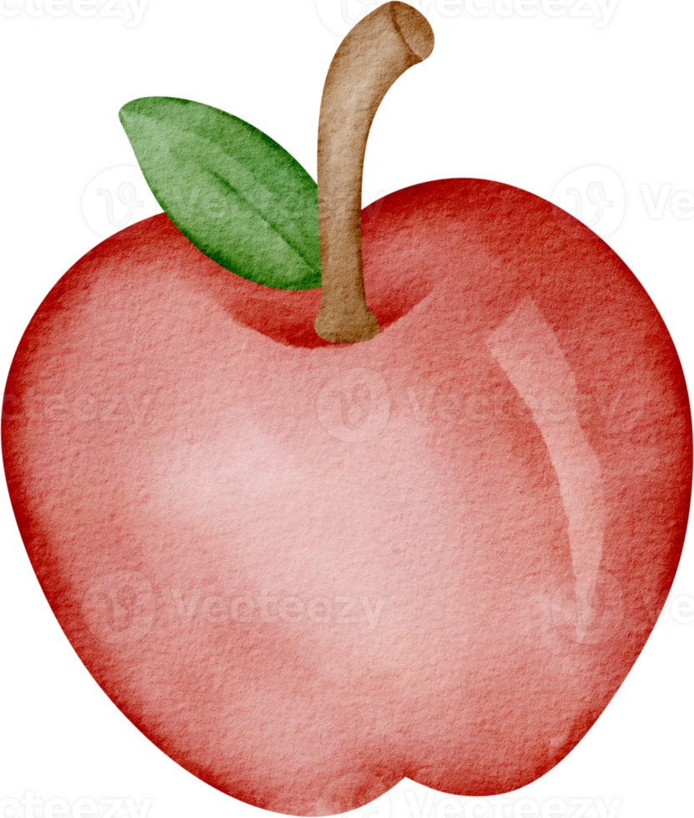

Apples are ripening,
Umbrellas are opening.
Trees turning red and gold,
Until the days grow cold.
Mushrooms grow beneth amber leaves.
Nothing beats the golden colours of autumn.

Nikol Medvedec, grade 7

