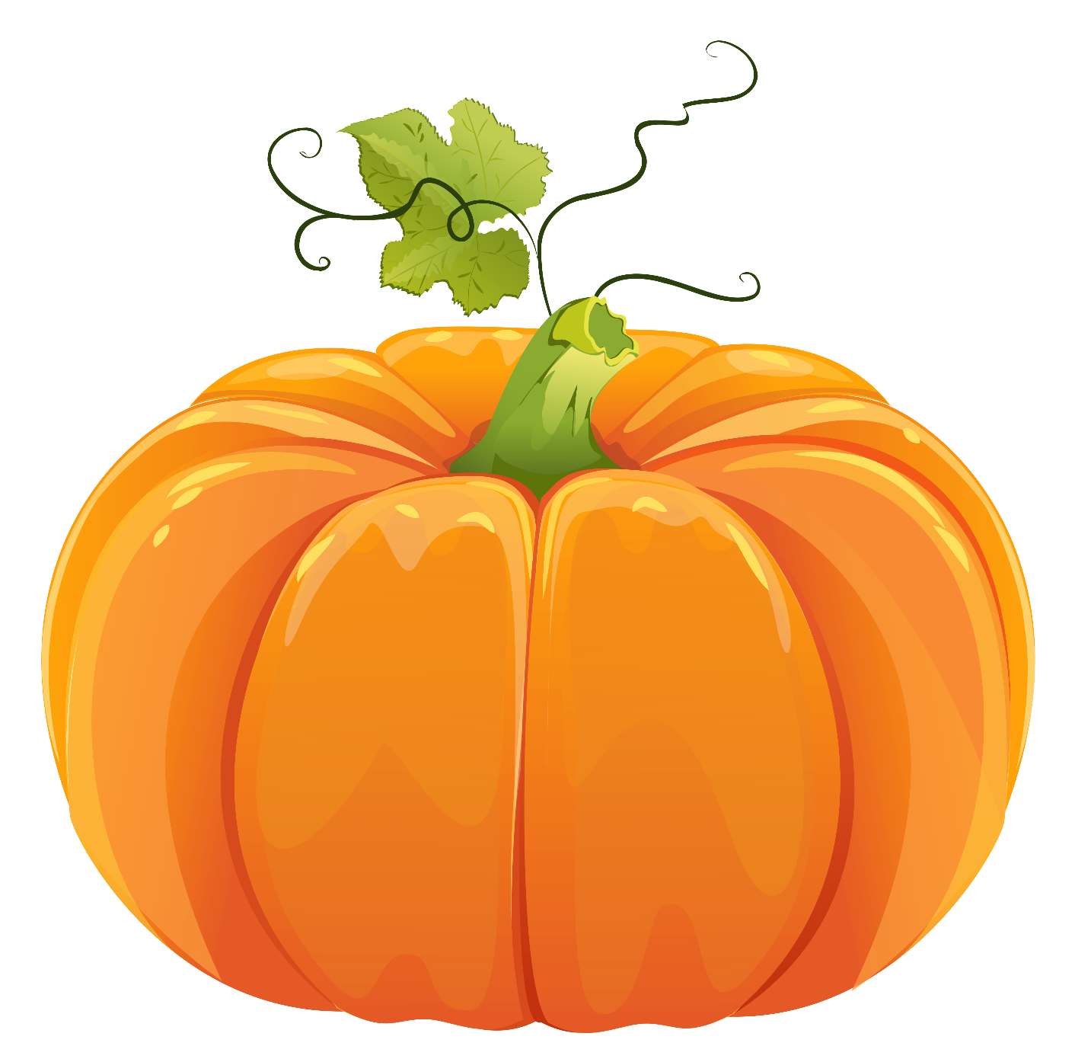

Pumpkins are orange and round,
Under the leaves, they can be found.
Many grow in autumn time,
Pumpkin pie is simply divine!
Kids love carving faces with care,
Inside are seeds we can share.
Now autumn fun is everywhere!
Jana Pongrac, grade 8

