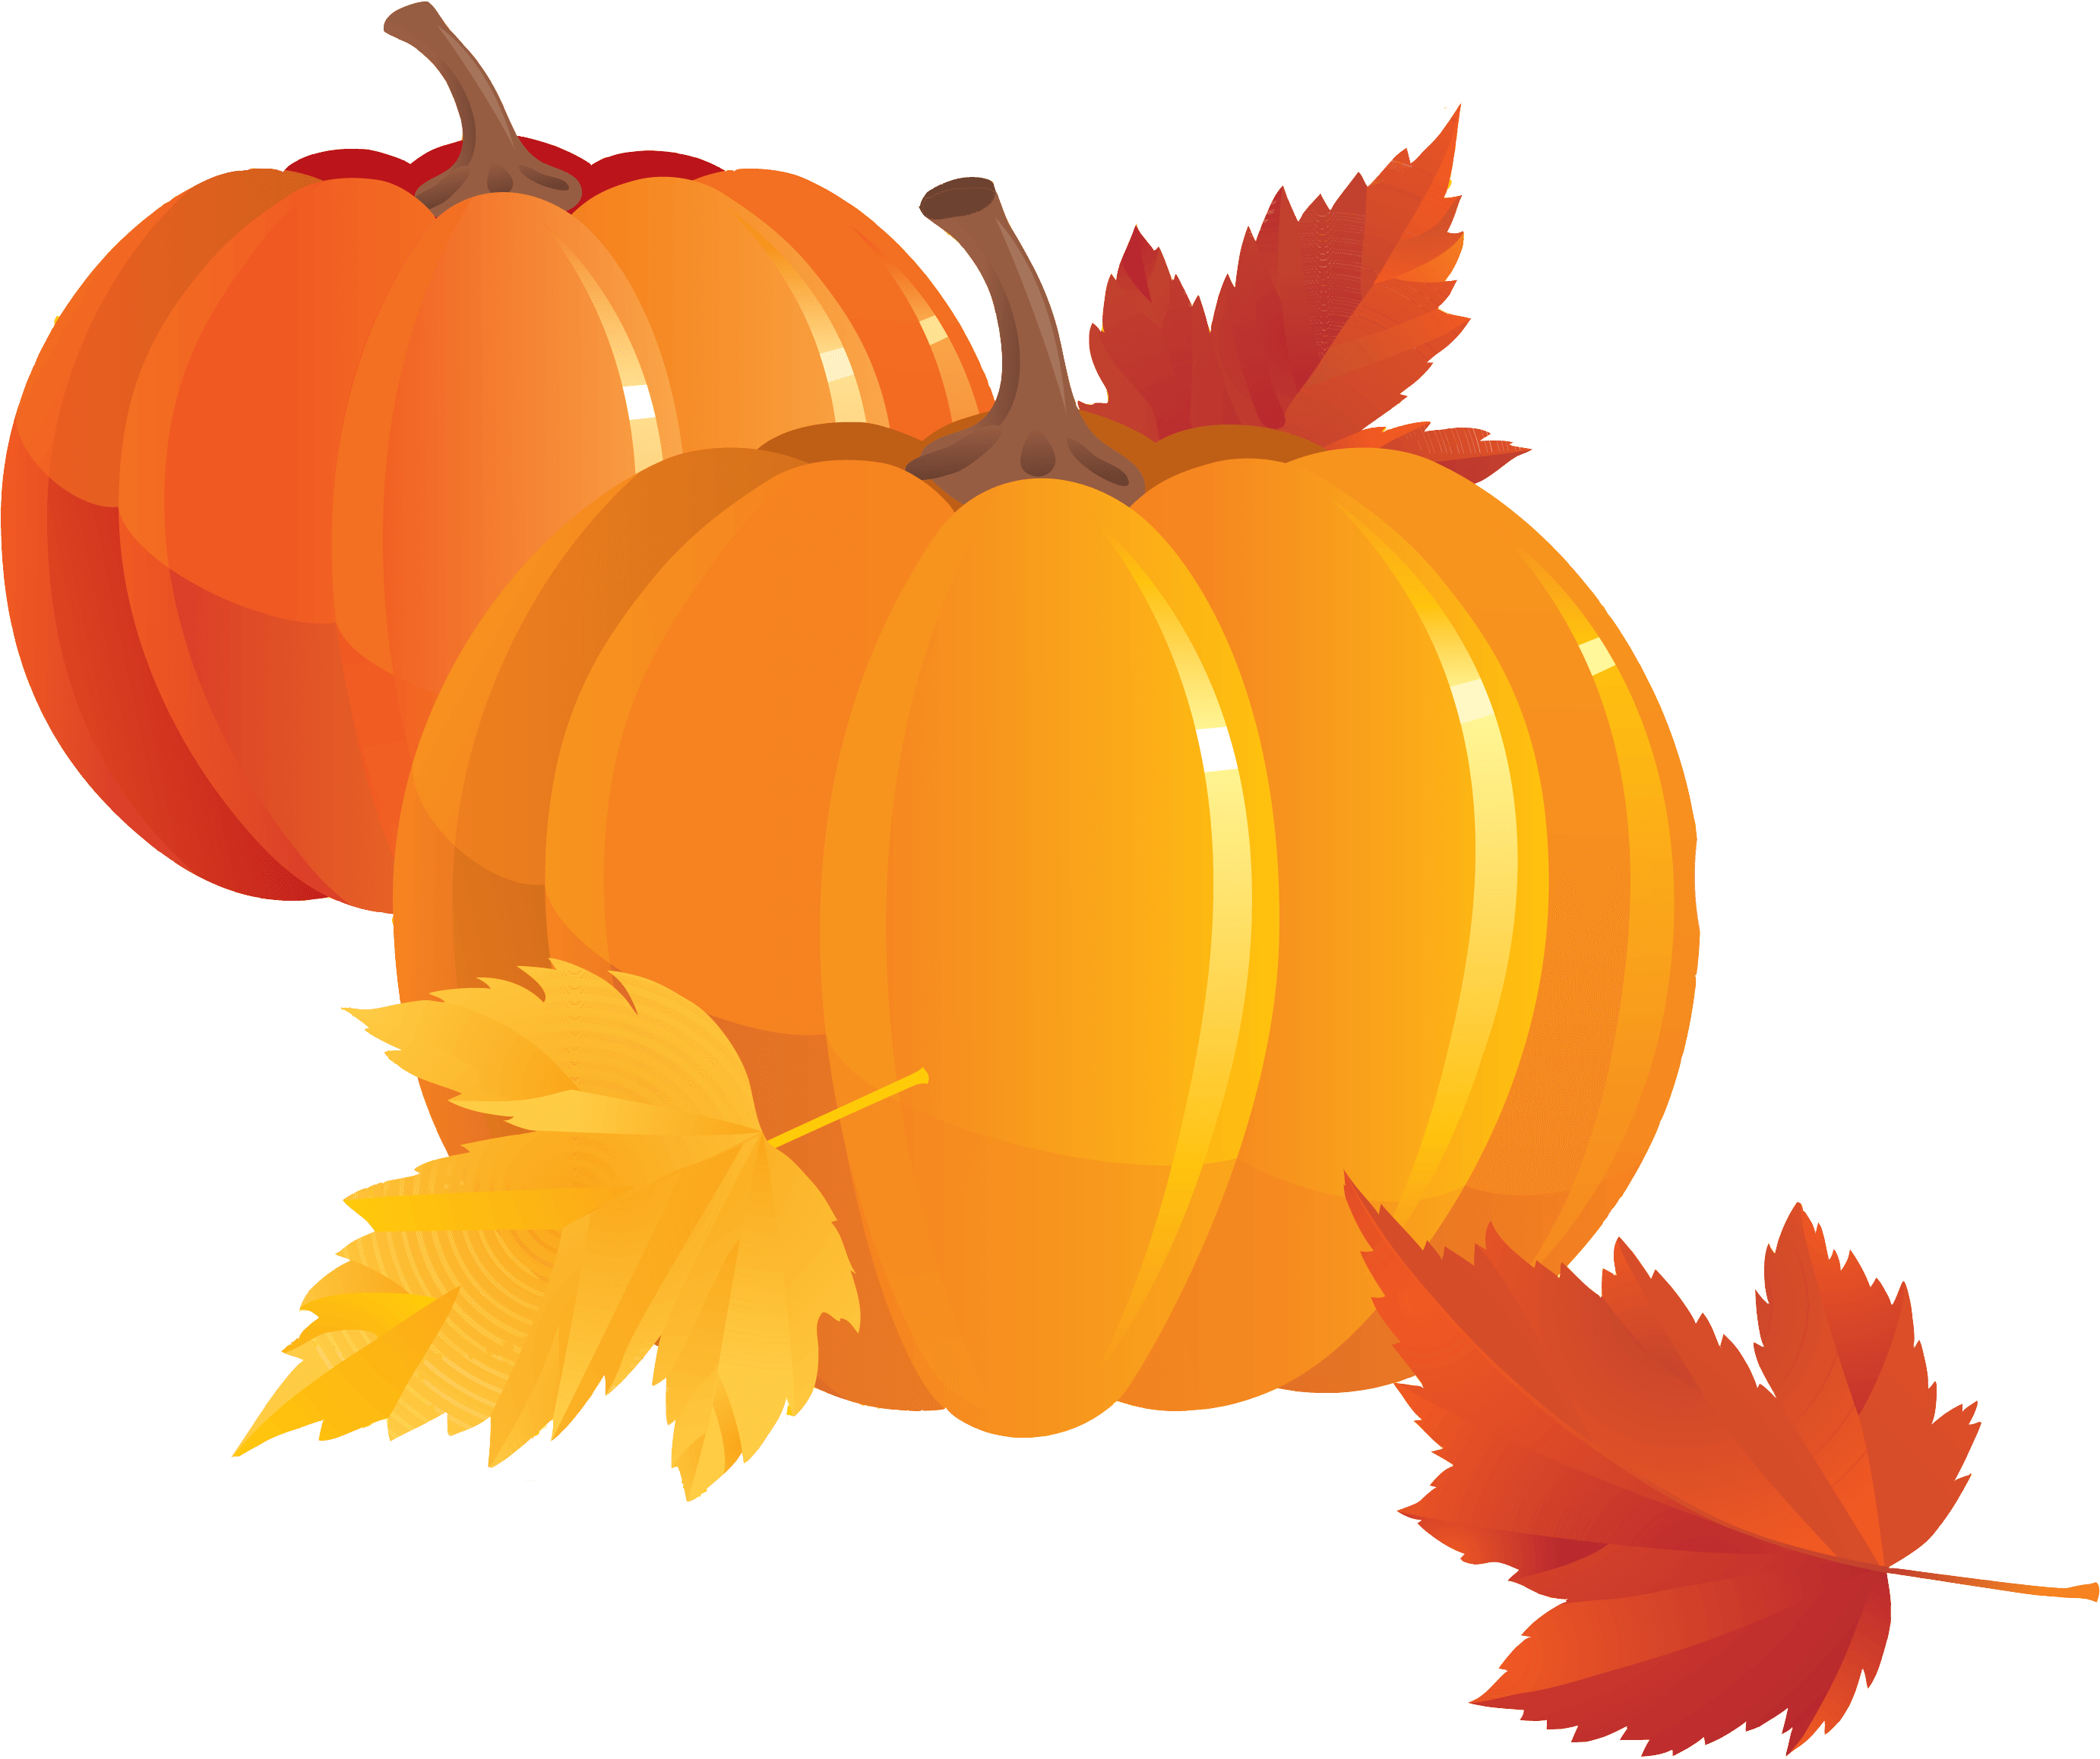

Pumpkins are big, orange or green
Under the autumn sky.
Many brown leaves fall down,
Picking the biggest one.
Kids wear heavy jackets and coats,
In the cold wind that blows.
Nature is gold, beautifully glows.

Helena Iveković, grade

